TREASURY STRATEGY · OPTIONS OVERLAY
Systematic Yield Generation for Token Treasuries
Monetizing token holdings through structured options programs
Executive Summary
Token treasuries can generate steady, repeatable income by systematically selling call options on existing holdings. Executed via a Request-for-Quote (RFQ) framework, this approach transforms idle assets into a structured yield program while managing token distribution and market impact in a controlled, predictable manner.

01 — The Underutilized Treasury Problem
Token treasuries — often holding significant portions of circulating supply — represent one of the largest underutilized asset bases in crypto markets. In most cases, these holdings generate no income and are only monetized through discretionary sales, which introduce timing risk and can cause market disruption.
At the same time, idle cash and stablecoins accumulate without active deployment. This creates a structural opportunity: to transform both token holdings and idle cash into systematic, income-generating assets through structured options strategies.

The core inefficiency
• Token holdings sit idle, generating zero yield
• Monetization relies on discretionary sales — introducing timing risk and sell pressure
• Idle cash and stablecoins are not actively deployed
• Large treasuries have sufficient scale to access institutional options markets via RFQ

02 — Strategy Design: Covered Call Overlay
The strategy is anchored around covered call selling as the primary income engine. By selling out-of-the-money calls — typically struck at 130–150% of spot — the treasury generates upfront premium income on existing holdings while remaining aligned with long-term distribution objectives.
This is a pre-programmed monetization strategy: if the option expires worthless, the treasury retains tokens and premium. If exercised, tokens are sold at a higher-than-spot price and the premium is kept. In both cases the outcome is economically consistent with gradual token distribution goals.

Covered call mechanics: Example
• Sell call struck at 130% of spot each month, receive e.g. $4 premium upfront
• Option expires worthless (price ≤ $130): keep tokens + full $4 premium
• Option exercised (price > $130): tokens are sold at $130 + keep $4 premium
• Repeat monthly — $48 annual income on a $100 token position (48% yield)
• Fully collateralized: existing token holdings cover any exercise obligation

For treasuries holding idle cash or stablecoins, the strategy can be extended with cash-secured put selling at 70–80% of spot. This generates additional premium income while introducing buy-side support if prices decline — creating a balanced two-sided flow profile.

03 — Yield Generation: A Recurring Income Stream
The primary objective is to generate consistent premium income from existing token holdings — income that does not depend on predicting price direction. Returns are driven by three repeatable mechanics:
- Premium collection: each option sale results in upfront cash inflow at trade inception
- Time decay: options lose value over time, working in favour of the seller throughout the cycle
- Repetition: executed monthly or even weekly, creating a compounding recurring revenue cycle across 12 periods

This transforms a non-yielding asset into a cash-flow-producing instrument, shifting the treasury from irregular market-timing-dependent inflows to a structured and forecastable revenue cycle. Income can be forecast and scaled based on position size and implied volatility levels.

04 — Execution: RFQ-Based Price Discovery
The Request-for-Quote (RFQ) model is a key structural advantage. Rather than relying on single brokers, trades are competitively priced across a network of market makers, delivering two primary benefits:
- Pricing dispersion capture: option quotes vary materially across providers, particularly in less liquid markets
- Reduced signaling risk: off-exchange execution avoids broadcasting intent to the market, though dealer hedging activity will still create directional flows in the underlying — a dynamic addressed separately in the market impact section.
RFQ transforms execution from a passive, price-taking process into an active price discovery mechanism, materially improving realized outcomes for large or complex trades.

05 — Market Impact: Managing Flow and Pressure
The strategy has direct implications for market dynamics through dealer hedging flows. When the treasury sells calls, market makers hedge by selling the underlying — introducing incremental sell pressure near the strike. Complementary put selling introduces buy pressure below spot, partially offsetting this and providing two-sided liquidity.
Dealer hedging is gradual, spread across the life of the option, and concentrated only near the strike — not a sudden block sale. Relative to average daily volume, the impact is typically modest, particularly for tokens with deep spot and perpetual markets. More broadly, the treasury is not selling tokens indiscriminately: it is committing to sell at a premium above current market levels if called upon to do so. That is a structurally different — and more orderly — form of distribution than discretionary spot sales, which can create sharper, less predictable pressure. A well-sized call overwriting program is therefore better understood as a stabilising presence in the market rather than a disruptive one.

Net market effect of the combined strategy
• Calls: premium income + controlled token distribution at elevated prices
• Puts: additional premium income + buy-side support on downside moves
• Combined: balanced two-sided flow profile, reducing one-sided sell pressure
• At sufficient scale, hedging flows can represent a meaningful share of daily volume

06 — Implications and Trade-offs
An RFQ-based options program repositions the token treasury across three dimensions simultaneously. Alongside these benefits, the strategy carries well-defined trade-offs that should be understood upfront.

Benefits | Trade-offs
• Income generation: converts volatility into recurring cash flow  • Market stabilization: dampens volatility, enhances price discovery  • Market influence: establishes implicit support and resistance levels | • Capped upside: participation in strong rallies is limited above the strike  • Assignment risk: large moves trigger exercise or forced purchases  • Perception: persistent call selling may be read as price resistance

Conclusion
Options-based strategies represent a structural evolution in crypto treasury management. By combining execution efficiency with systematic premium collection, these programs enable treasuries to convert idle assets into recurring income streams.
Rather than relying on discretionary token sales, foundations can implement a structured yield program that aligns with long-term distribution objectives while improving cash flow visibility. In this framework, token treasuries evolve from passive holders into active income-generating portfolios, with the ability to manage both inventory and market impact in a controlled and predictable manner.

APPENDIX · TECHNICAL REFERENCE
Call Overwriting: Payoff Structure for the Educated Reader
The diagram below illustrates the precise payoff structure of a call overwriting strategy from the treasury’s perspective. At every market price below the $130 strike, the covered call curve sits exactly $48 above the unhedged token position — the full annual premium already collected. Above the strike, the curve goes flat: the token is delivered at $130, premium is retained, and any further appreciation accrues to the option buyer.
The strategy is not directionally bearish. It is indifferent to whether the token rises or falls below the strike. The only cost is opportunity: gains above $130 are foregone in exchange for the certainty of $48 income per token per year.

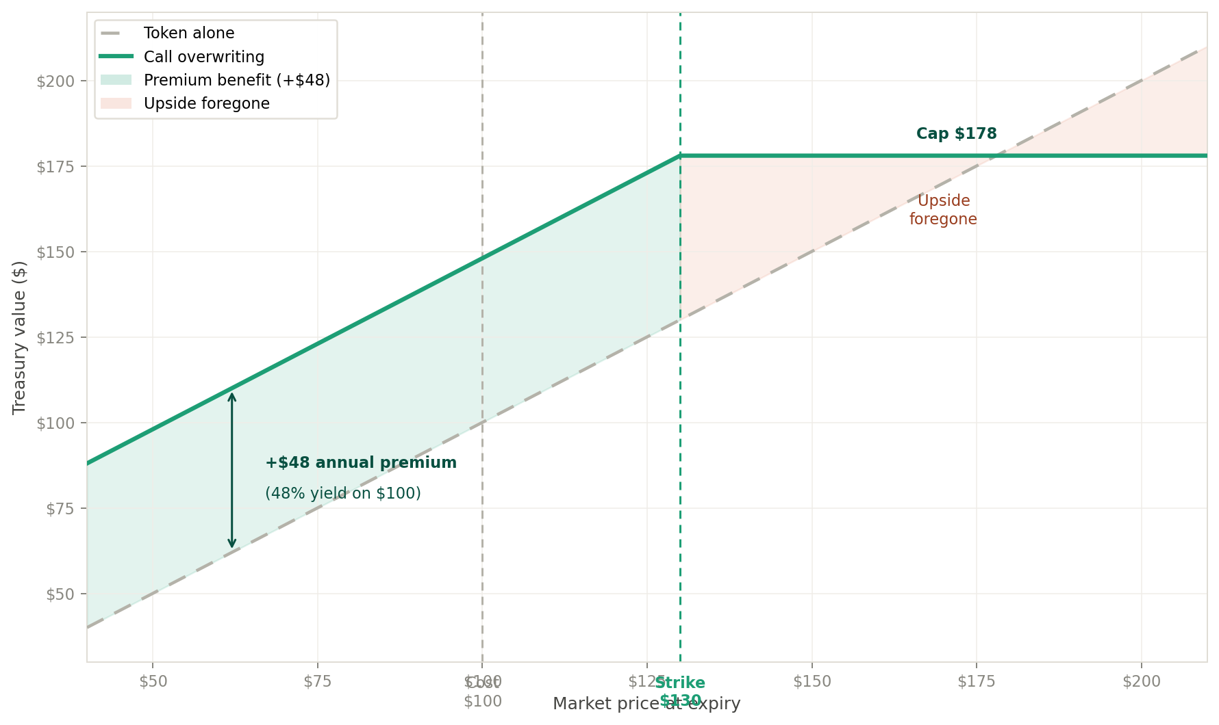
Fig. A1 — Call overwriting payoff at expiry. Token cost $100, strike $130 (130% of spot), $4 monthly premium × 12 cycles = $48 annual yield (48%). Green band: premium benefit. Coral zone: upside foregone above strike.
ANNUAL PREMIUM  $48  $4/month × 12 cycles | ANNUAL YIELD  48%  on $100 token cost | MAX VALUE  $178  strike $130 + premium $48 | DOWNSIDE BUFFER  $48  breakeven at $52

Key observations for the practitioner:
- The $48 annual premium provides a $48 downside buffer — the position only loses money if the token falls below $52 (breakeven), a 48% decline from cost
- Above the strike, the treasury still outperforms an unhedged position by $48 per token — the premium is kept regardless of exercise
- The strategy’s attractiveness scales with implied volatility: higher vol means higher premiums for the same strike distance
- Monthly re-execution allows the strike to reset with the market, maintaining the 130% target ratio across different price levels

